# **Tenses**

There are three main tense.

### **1) Present**

**Simple**

* **Urdu**: میں پڑھتا ہوں، لکھتا ہوں، وہ گاتا ہے، وہ کھیلتا ہے، ہم دوڑتے ہیں
* **English**: I read, I write, he sings, he plays, we run

**Continuous**

* **Urdu**: میں لکھ رہا ہوں، میں پڑھ رہا ہوں، وہ سو رہی ہے، بچے کہانی سن رہے ہیں
* **English**: I am writing, I am reading, she is sleeping, children are listening to a story

**Perfect**

* **Urdu**: میں نے لکھ دیا ہے، میں نے کھا لیا ہے، ہم نے کتاب پڑھ لی ہے، اس نے کام مکمل کر لیا ہے
* **English**: I have written, I have eaten, we have read the book, he has completed the work

**Perfect Continuous**

* **Urdu**: میں دو گھنٹوں سے پڑھ رہا ہوں، وہ صبح سے کام کر رہی ہے، ہم گھنٹوں سے انتظار کر رہے ہیں
* **English**: I have been reading for two hours, she has been working since morning, we have been waiting for hours

### **2) Past**

**Simple**

* **Urdu**: میں نے لکھا، پڑھا، کھایا، ہم نے فلم دیکھی، اس نے کام کیا
* **English**: I wrote, I read, I ate, we watched a movie, he worked

**Continuous**

* **Urdu**: میں لکھ رہا تھا، پڑھ رہا تھا، کھا رہا تھا، بچے شور مچا رہے تھے، وہ کتاب لکھ رہی تھی
* **English**: I was writing, I was reading, I was eating, children were making noise, she was writing a book

**Perfect**

* **Urdu**: میں نے لکھ دیا تھا، میں نے پڑھ لیا تھا، اس نے کھانا کھا لیا تھا، ہم نے کام ختم کر لیا تھا
* **English**: I had written, I had read, he had eaten food, we had finished the work

**Perfect Continuous**

* **Urdu**: میں دو گھنٹوں سے پڑھ رہا تھا، وہ گھنٹوں سے اپنی کتاب لکھ رہی تھی، بچے شام سے پڑھائی کر رہے تھے
* **English**: I had been reading for two hours, she had been writing her book for hours, children had been studying since evening

### **3) Future**

**Simple**

* **Urdu**: میں پڑھوں گا، کھاؤں گا، ہم سکول جائیں گے، وہ اپنا کام مکمل کرے گا
* **English**: I will read, I will eat, we will go to school, he will complete his work

**Continuous**

* **Urdu**: میں پڑھ رہا ہوں گا، لکھ رہا ہوں گا، وہ کہانی سن رہا ہوگا، بچے باغ میں دوڑ رہے ہوں گے
* **English**: I will be reading, I will be writing, he will be listening to a story, children will be running in the garden

**Perfect**

* **Urdu**: میں نے لکھ دیا ہوگا، میں نے پڑھ لیا ہوگا، ہم نے کھانا کھا لیا ہوگا، بچوں نے ہوم ورک ختم کر لیا ہوگا
* **English**: I will have written, I will have read, we will have eaten, children will have completed their homework

**Perfect Continuous**

* **Urdu**: میں دو گھنٹوں سے پڑھ رہا ہوں گا، وہ کئی دنوں سے لکھ رہا ہوگا، بچے دوپہر سے کھیل رہے ہوں گے
* **English**: I will have been reading for two hours, he will have been writing for many days, children will have been playing since afternoon

# **Present Indefinite / Simple Tense:**

The **Present Simple Tense** is used to describe actions, events, or situations that are:

1. **Habitual or Regular**: Things that happen repeatedly or regularly.
2. **General Truths or Facts**: Statements that are always true.
3. **Scheduled or Timetabled Events**: Future events with a fixed schedule.
4. **States**: Permanent or unchanging situations.

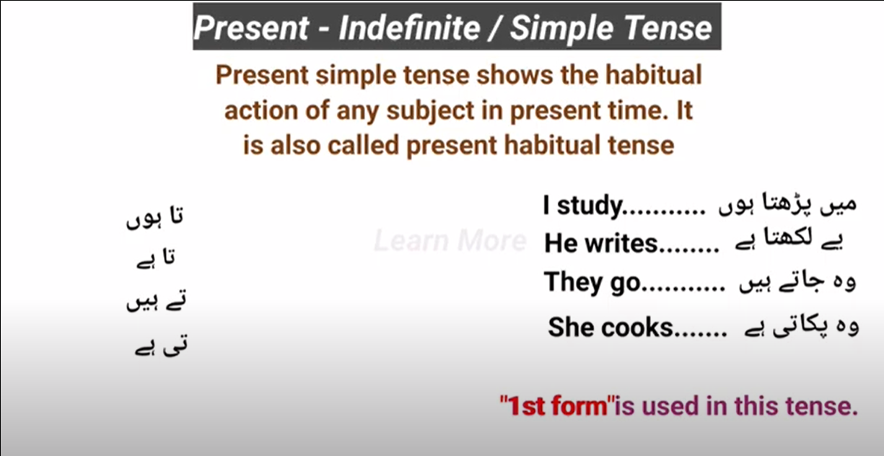

## **Helping Verb:**

1. Do
2. Does

**Note**: Both **do and does** only used in **negative, interrogative, (interrogative: negative) or in emphatic sentences.**

|  |  |
| --- | --- |
| **Do** | **Does** |
| * I * We * You * They * Plural Subject: (Bilal and Haseeb) | * He * She * It * Singular Subject: (Nadir) |

## **Kind of Sentences:**

1. **Positive/Assertive/Affirmative/Declarative Sentences:**

**Formation:**

(**Third-person singular:** He, she, it, nadir)

Subject + (V1) M.V (main verb (+ s/es for third-person singular)) + Object + .

**Examples:**

* I + go + to + school + .
* They + play + cricket + .
* She + Cooks + Biryani

**Rules for adding e/es in singular subject:**

If the subject is **singular** like **he, she or it** and its verb is end with ‘y’ and before ‘y’ we have **consonant** then we remove ‘y’ and add **ies** and if we have vowels before ‘y’ then we just add ‘s’.

|  |  |  |  |
| --- | --- | --- | --- |
| **Consonant** |  | **Vowels** |  |
| Cry | Nadir cries | Play | Nadir Plays |
| Shy | She shies | Say | He says |
| Try | He tries | Stay | She stays |
|  |  |  |  |

If the subject is **singular** like **he, she or it** and its verb is end with words like **“ss, sh, ch, x, o”** then we add **es**

|  |  |  |
| --- | --- | --- |
| Kiss | Kisses | She kisses her child. |
| Smash | Smashes | He smashes her TV. |
| Snatch | Snatches | He snatches toys from children. |
| Box | Boxes | He boxes his opponent forcely. |
| Go | Goes | He goes to office by foot. |

If the subject is **singular** like **he, she or it** and its verb is **not** end with **‘Y’** like **“speak, run”** then we add **s**

|  |  |  |
| --- | --- | --- |
| Speak | Speaks | She speaks. |
| Run | Runs | He runs. |

## **Practice:**

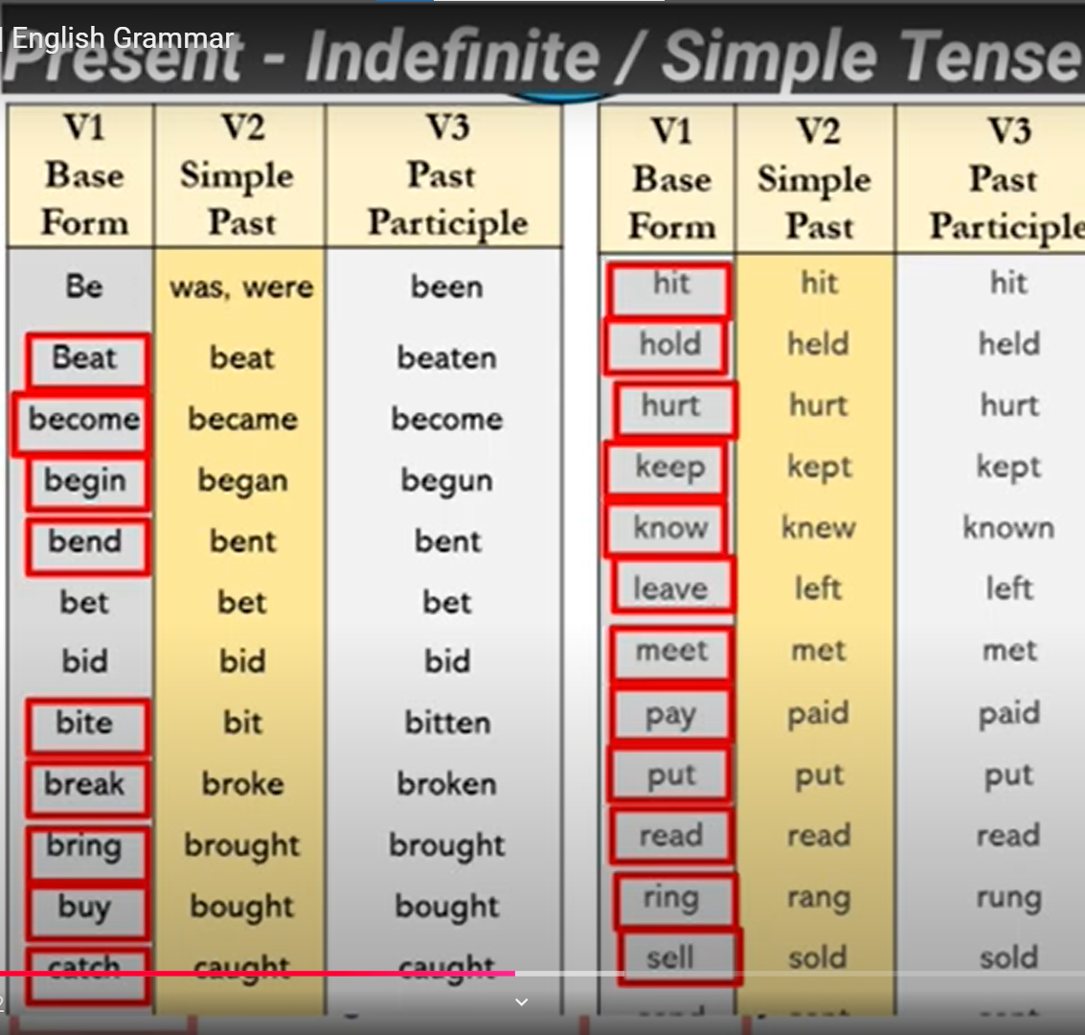

1. **Negative Sentences**:

**Formation:**

Subject + H.V + not + (Verb 1st Form) + Object + .

**Examples**:

* I + do + not + go + to + school + .
* They do + not + play + cricket + .
* She + does + not + Cook + Biryani +.
* He + does + not + play + cricket +.

1. **Interrogative Sentences**:

**Formation:**

H.V (Do/Does) + Subject + (Verb 1st Form) + Object + ?

**Example**:

* Do + I + go + to + school +?
* Do + they + study + English +?
* Does + he + watch + cricket +?

1. **Interrogative: & Negative Sentences**:

**Formation:**

H.V (Do/Does) + Subject + not + (Verb 1st Form) + Object + ?

**Example**:

* Do + I + not + go + to + school +?
* Do + they + not + study + English +?
* Does + he + not + watch + cricket +?
* Do + you + not + each + rice and potatoes +?

1. **Emphatic Sentence:**

**Formation:**

Subject + H.V (Do/Does) + (Verb 1st Form) + Object + ?

**Example**:

* I like to eat mangoes.
* I do like to eat mangoes.
* Doctor serves the nations.
* Doctor does serve the nations.

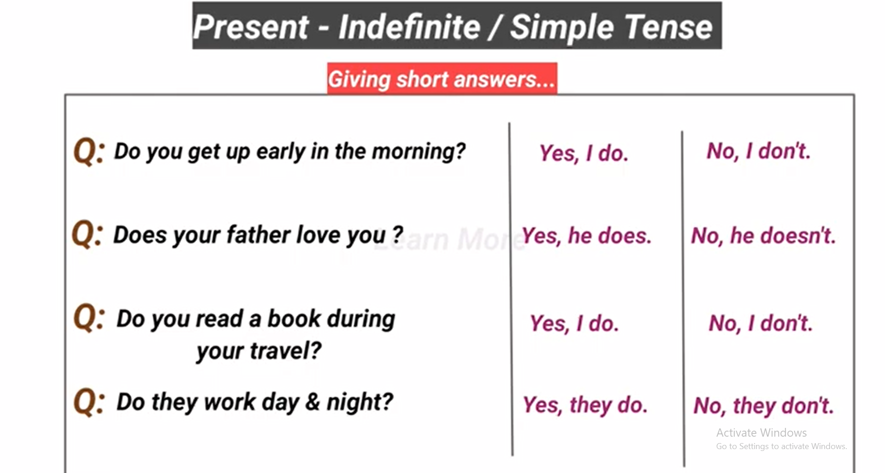

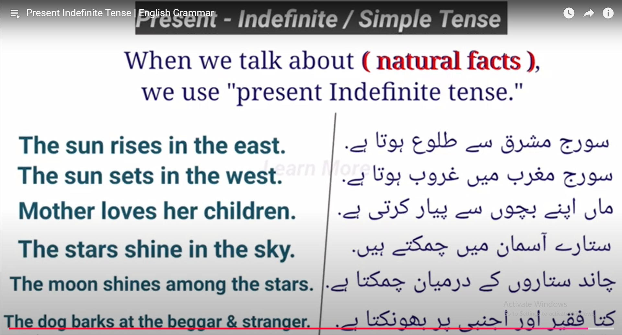

# **Present Continuous Tense:**

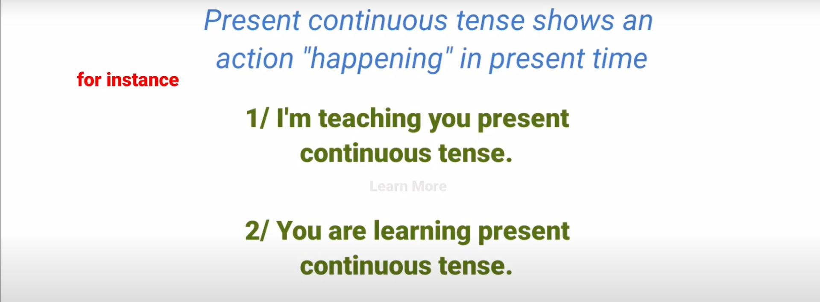

## **Helping Verb:**

|  |  |
| --- | --- |
| Is | He, she, it & nadir (Singular Subject) |
| Am | I |
| Are | We, They, you and (Nadir and Haseeb) |

**Note:** 1st Form of verb + ing is used in this tense. e.g. Playing , Calling , Working etc.

**Important Rules:**

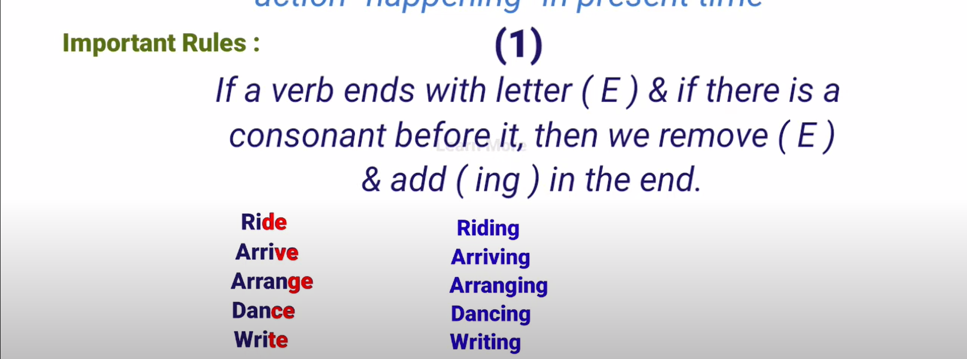

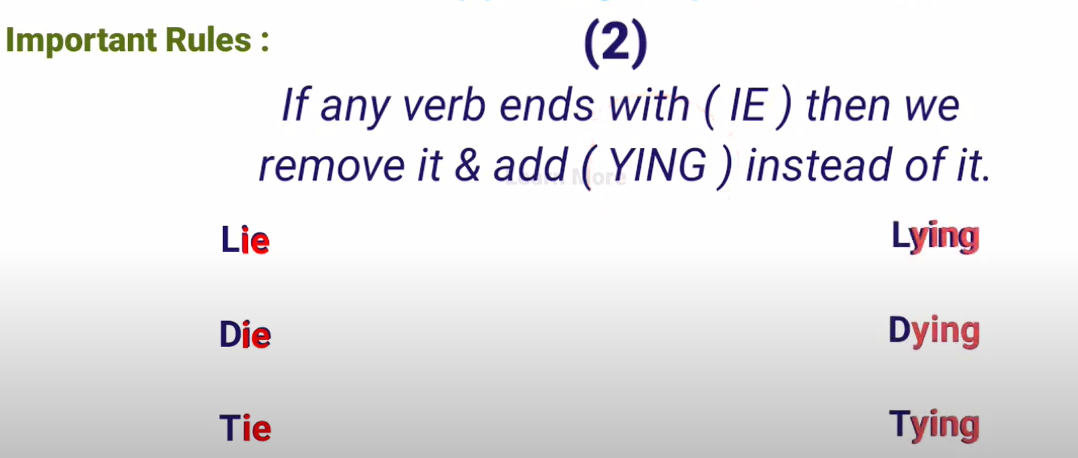

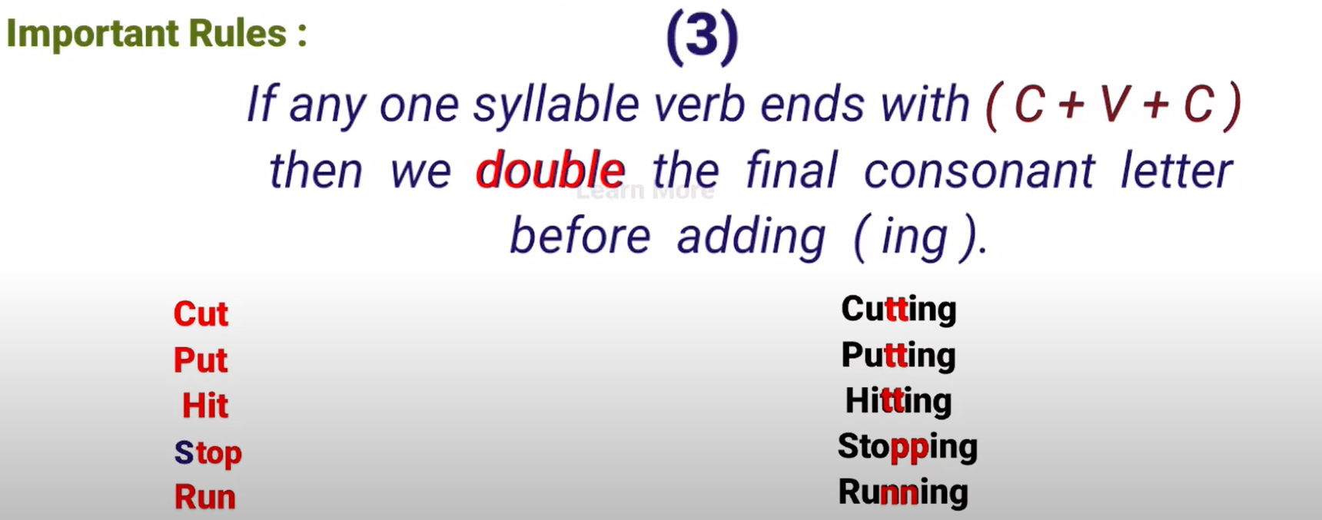

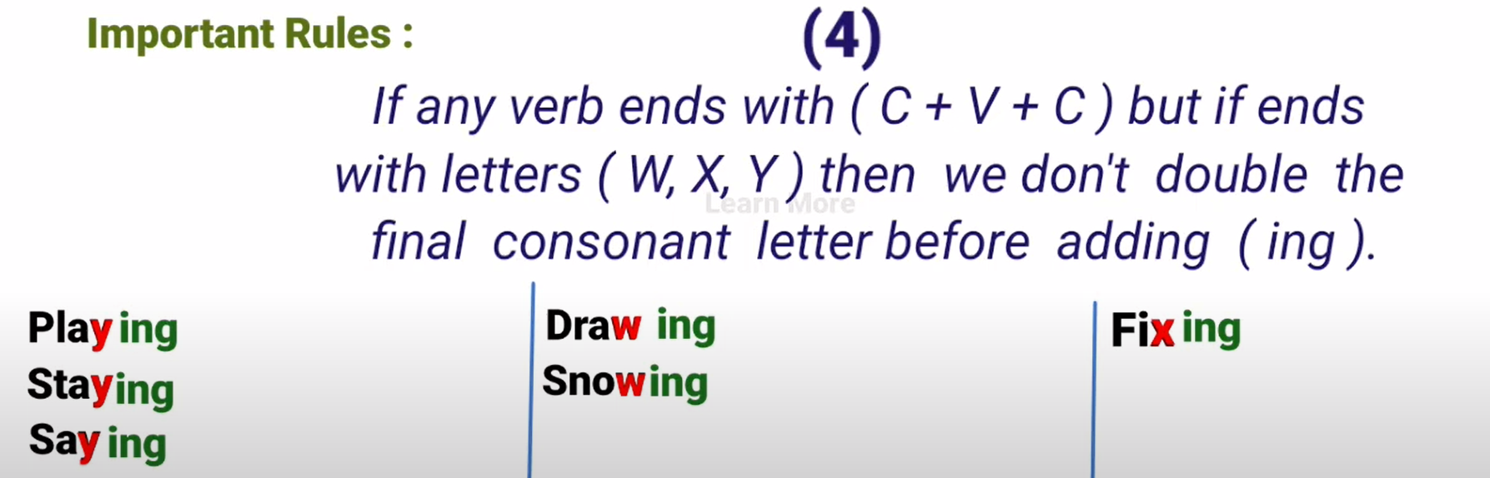

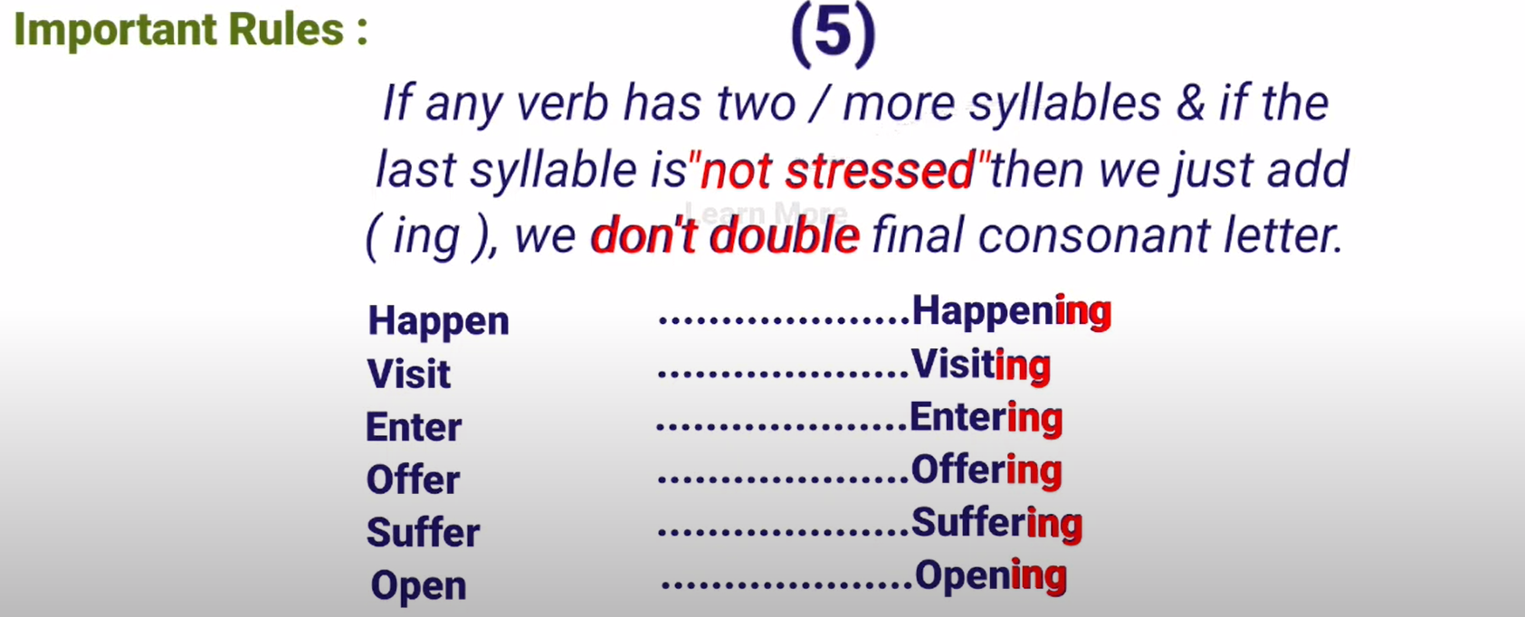

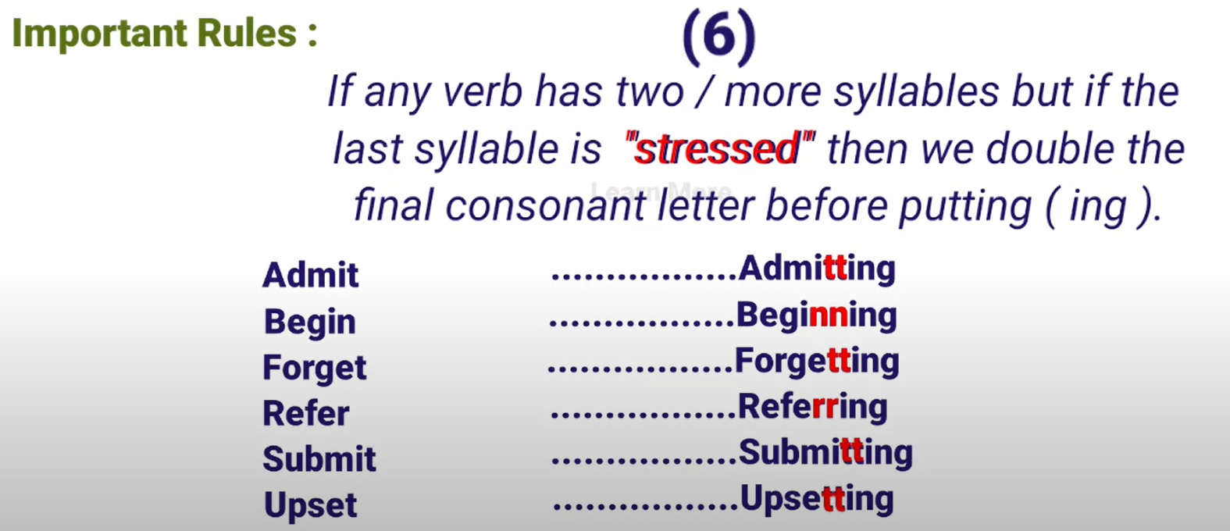

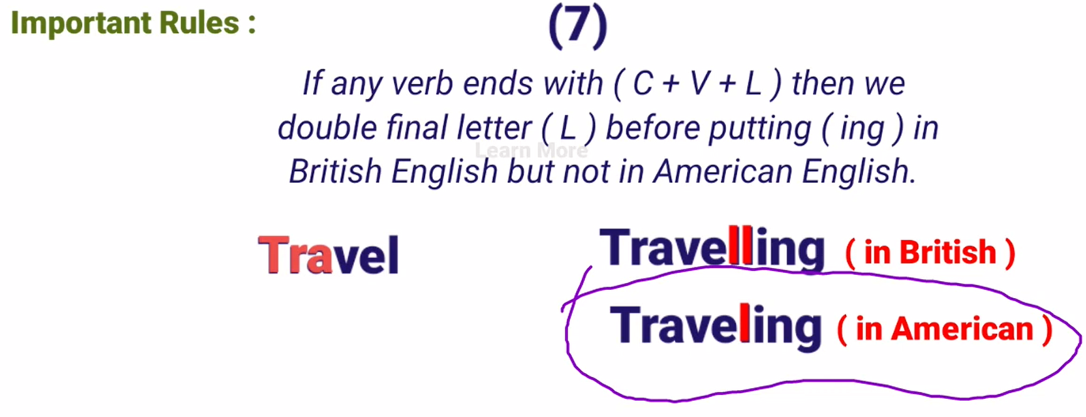

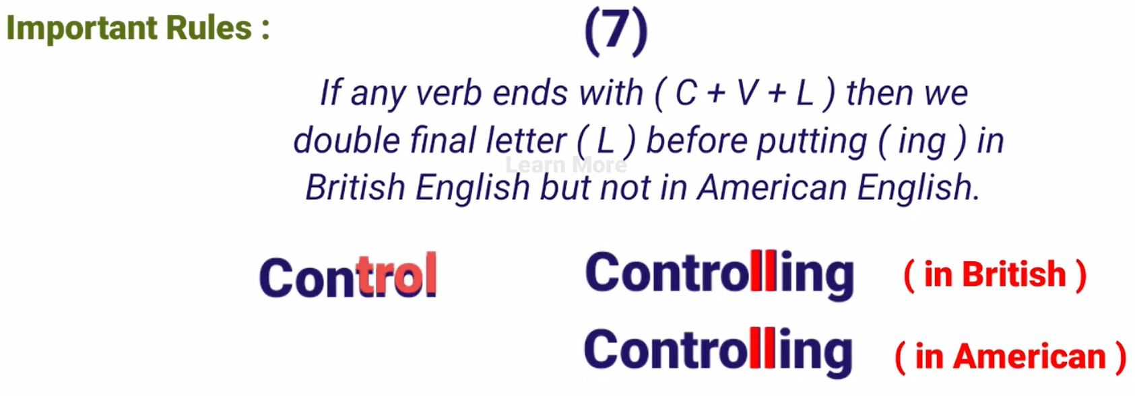

## **Kind of Sentences:**

